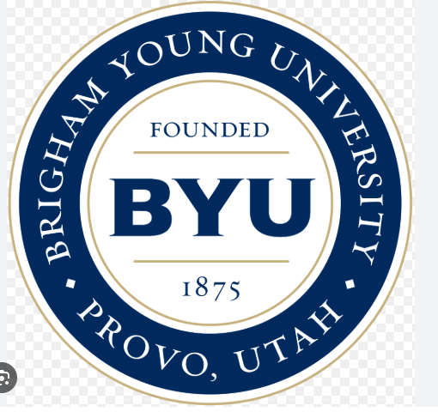
Brigham Young University

W07 REFLECTION

Leida J. Pereira Hidrogo
Department, BYU-Idaho
REL250A: Religion
Sister Luanne Simmons
Date: December 12, 2025
Reflection:
What miracles have you personally witnessed in your life? How have those experiences strengthened your faith in Heavenly Father and Jesus Christ?
I am a miracle. I spent years as an investigator, but I didn't want to be baptized. When my sister went on her mission, she became ill and came home for a month to recover. During that time, I listened to the lessons and was baptized. Truly, if it hadn't been for her, perhaps it would have taken me longer, or maybe I wouldn't have been baptized at all. Later, once she had recovered, she returned to her mission; it was a wonderful experience. Currently, after being baptized for many years, I have had several callings, worked with the CES (Church Educational System), served a mission, and was sealed in a holy temple.
My faith has been strengthened enormously. I truly know that Our Heavenly Father is a real being. I know that Jesus Christ lives and that He directs the Church Himself. I know that faith is a principle with power. I know that the Book of Mormon is another testament of Jesus Christ.

